Template for Extended Abstracts for the 4th International Conference on Library and Information Management (ICLIM 2021)

First A. Author*¹, Second B. Author² and Third C. Author³

^{1, 2} Authors’ Department, Institute, Organisation, Country
(E-mail: firstauthorsname@aaaa.bbb, secondauthorsname@aaaa.bbb)
³ Author’s Department, Institute, Organisation, Country
(E-mail: thirdauthorsname@aaaa.bbb)

Abstract: Abstract should be written with 10 font size, Times New Roman, single line spacing. The abstract should be concise and should contain no more than 300 words

Keywords: This section should contain a maximum 5 words separated by commas.

EXTENDED ABSTRACT

This document presents the instructions needed to prepare the extended abstract (2-4 pages (1000-1500 words) in length including references) to be included in the proceedings of the ICLIM 2020.

The title (14 point, bold), authors’ names (12 point), and affiliations (10 point) should be set flush-centre. Please leave one blank line (12 point) after the title as well as after the list of authors.

All abstracts should be written in English. In order to achieve graphical consistency, the extended abstract should be written using Microsoft Word. It should be A4 size paper with margin 1.5 cm on all sides in MS Word format in 12 points New Times Roman type single line spacing Length of the Extended Abstract should be min 2 and max 3 pages (1000-1500 words) excluding references.

The body text itself should be left and right justified. The extended abstract should contain the following sections: Should include Introduction, Objectives, Methodology, Results, Discussion/Conclusion, and Recommendations with related references, with each section headline written with Times New Roman font, 12 font size, bold, and all caps. These sections can be named differently and subsections can be included. The extended abstract can contain figures, tables and images. Pages should not be numbered.

Authors are requested to submit Abstracts via duly filled submission form. Accepted formats is MS Word.

Supporting figures, tables and images may be included. All the tables, images and figures should be centered. Figures and images should be numbered and figure captions should be placed under the figure or image. Please see Figure 1 for an example. The tables should also be numbered and the table caption should be placed at the top. Please see Table 1 for an example.

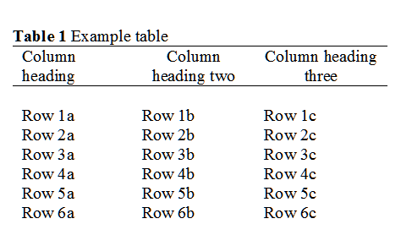

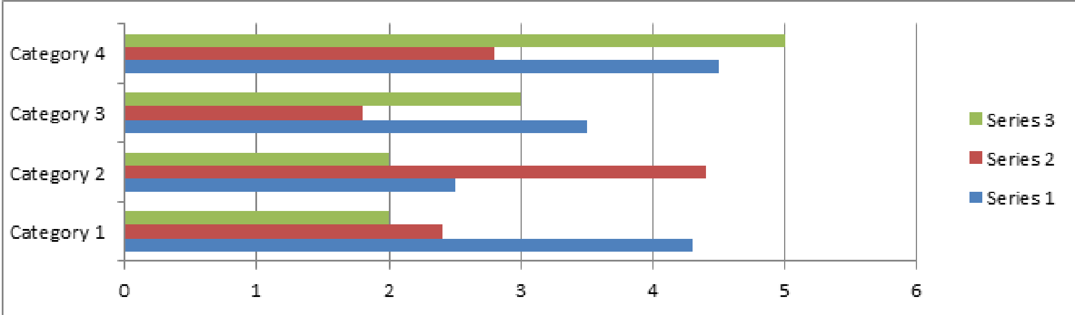
Figure 1. Example graph for the extended abstract.

REFERENCES
References that have been presented inside (Auhtors, Year) in the full text should be prepared in the format of APA 7th as shown below:

Australian Institute of Health and Welfare. (2018, June 20). Australia's health 2018 (Report No. 16, Aus 221). Australian Government. https://www.aihw.gov.au/getmedia/7c42913d-295f-4bc9-9c24-4e44eff4a04a/aihw-aus-221.pdf.aspx?inline=true
James Cook University. (2021). Borrow and renew. https://www.jcu.edu.au/library/loans
Morgan, R., Meldrum, K., Bryan, S., Mathiesen, B., Yakob, N., Esa, N., & Ziden, A. A. (2017). Embedding digital literacies in curricula: Australian and Malaysian experiences. In G. B. Teh & S. C. Choy (Eds.), Empowering 21st century learners through holistic and enterprising learning: Selected papers from Tunku Abdul Rahman University College International Conference 2016 (pp. 11-19). Springer. https://doi.org/10.1007/978-981-10-4241-6_2
Queensland Health. (2016, July 26). Food safety fact sheet 51: Food allergies. Queensland Government. http://www.health.qld.gov.au/foodsafety/Documents/fs-51-allergies.pdf
Oshima, A., & Hogue, A. (2007). Introduction to academic writing. Pearson/Longman.
Smith, R. P., Easson, C., Lyle, S. M., Kapoor, R., Donnelly, C. P., Davidson, E. J., Parikh, E., Lopez, J. V., & Tartar, J. L. (2019). Gut microbiome diversity is associated with sleep physiology in humans. PLOS ONE, 14(10), Article e0222394. https://doi.org/10.1371/journal.pone.0222394

